ASSIGNMENT REPORT
Machine Learning-Based Time Series Forecasting Using Classical Statistical Models and Deep Learning
MODULE: Advanced Research Topics in Data Science
MODULE CODE:7PAM2016
STUDENT NAME: Dharanidhar Beere
STUDENT ID:24077147
1. Introduction
Time series forecasting aims to predict future observations using historical data and is widely used in applications such as demand forecasting, weather prediction, and energy management. Both weekly and hourly observations were used in the analysis of the German electricity demand dataset that was acquired from Open Power System Data. While the original hourly data were kept for LSTM modelling, weekly data were utilized for statistics and machine learning models. The workflow begins with data preprocessing and exploratory data analysis, followed by stationarity testing using the Augmented Dickey–Fuller (ADF) and KPSS tests. Forecasting models including Mean Forecast, Naïve Forecast, Seasonal Naïve, Drift, SARIMA, SARIMAX, Gradient Boosting Regressor, and Long Short-Term Memory (LSTM) are then trained and evaluated. Model performance is assessed using Root Mean Squared Error (RMSE) and Mean Absolute Error (MAE), where lower values indicate better forecasting accuracy.The primary objective is to identify the model that provides the most accurate forecasts while analysing how different techniques capture trend, seasonality, and temporal dependencies within the dataset.
2. Dataset and Preprocessing
The Open Power System Data repository's German electricity demand dataset, which covers hourly power demand from January 1, 2015, to October 2020, was used in the analysis. The timestamp column was converted to datetime and set as the data frame index in order to format the dataset for chronological analysis after it was filtered for Germany (country identifier DE). The dataset was examined for duplicates and missing values before analysis. The LSTM model was trained on hourly data, but benchmark models such as SARIMA, SARIMAX, and Gradient Boosting Regression employed weekly data. The Pandas resampling tool combined hourly data into daily and weekly observations. To provide realistic forecasting possibilities, the dataset was divided chronologically into training and testing sets, with the final two years set aside for testing.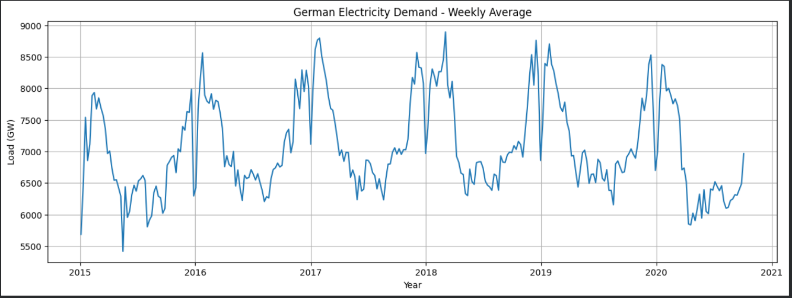
(Figure 1.Original Time Series)

3. Exploratory Data Analysis
The weekly German power demand data was subjected to an exploratory data analysis (EDA) prior to forecasting model development. With electricity consumption peaking and falling at different periods of the year, the first time-series plot shows discernible oscillations and a distinct seasonal pattern. The dataset is suitable for seasonal forecasting models such as Seasonal Naïve, SARIMA, and SARIMAX because it indicates the impact of seasonality beyond random fluctuations.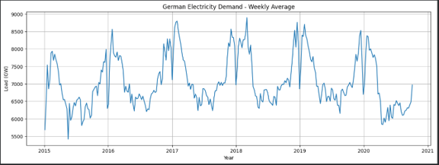
(Figure 2:Weekly German Electricity Demand (2015–2020). The figure illustrates the weekly electricity demand from January 2015 to October 2020, showing clear seasonal fluctuations and long-term variation in electricity consumption.)
The dataset was analyzed using a boxplot and histogram. The histogram reveals that the majority of weekly power demand values are somewhat variable and concentrated in a small range. A number of outlier observations outside of the interquartile range are confirmed by the boxplot and are kept because they most likely reflect real variations in the demand for energy brought on by seasonal weather, public holidays, and shifts in consumer behavior.
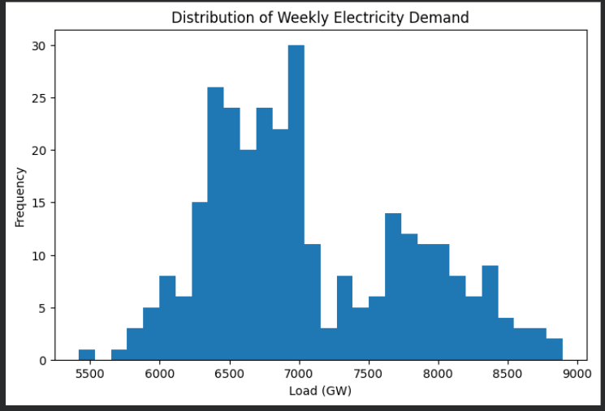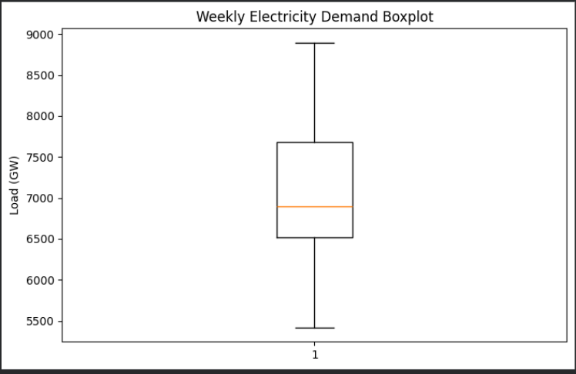
(Figure 3. Histogram of Weekly Electricity Demand.) (Figure 4. Boxplot of Weekly Electricity Demand.)
Seasonality is a significant feature of the dataset, evidenced by a clear and consistent seasonal pattern. The residual component fluctuates around zero with no discernible pattern, while the trend component reveals gradual changes in electricity demand. This indicates that random fluctuations are left in the residuals, with the trend and seasonal components responsible for most of the series' volatility, laying a strong foundation for the subsequent analysis of stationarity.
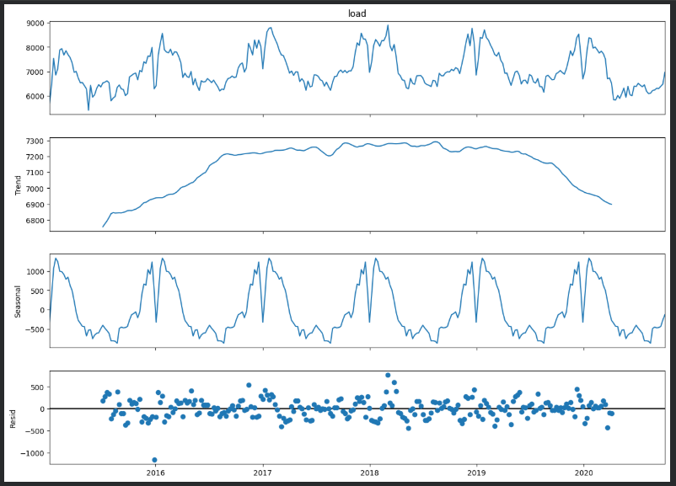(Figure 5. Histogram of Weekly Electricity Demand.)
4.Stationarity Test Results
The weekly electricity demand series was subjected to stationarity analysis prior to the forecasting models being developed. Because the statistical characteristics of the data, such mean and variance, should be largely constant throughout time, stationarity is a crucial prerequisite for statistical forecasting models.
To visually evaluate the series' stability, the rolling mean and rolling standard deviation were first looked at. The findings demonstrated that while there are occasional seasonal variations, the series' overall behavior is generally steady.

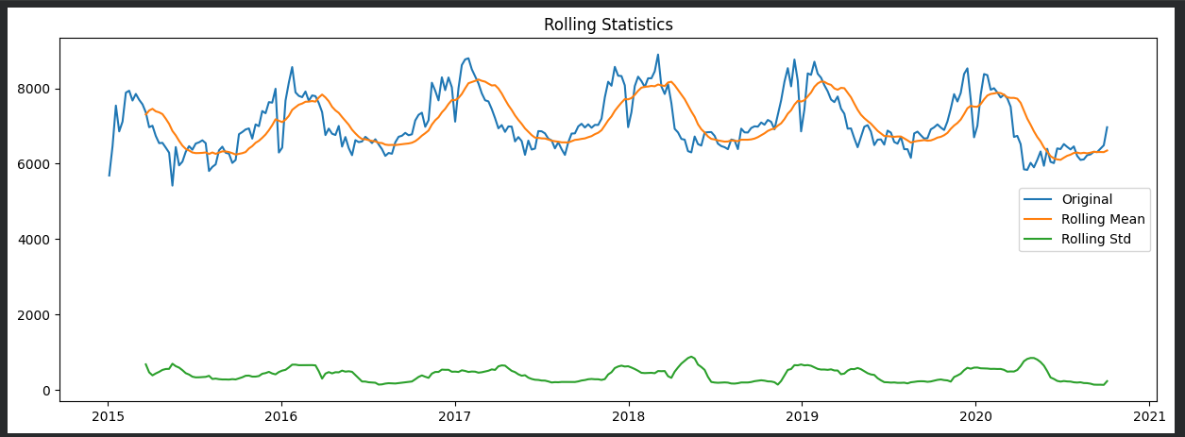
(Figure 6. Rolling Mean and Rolling Standard Deviation of Weekly Electricity Demand.)
To determine the dependence between the present and prior observations, the Autocorrelation Function (ACF) and Partial Autocorrelation Function (PACF) were examined. Significant autocorrelation was seen in the ACF plot at various lag values, suggesting that past demand values have an impact on subsequent data. The weekly data may have yearly seasonality if there are recurring trends at seasonal lags. Potential autoregressive correlations were found and the choice of SARIMA parameters was supported by the PACF plot.
Table 1. Stationarity Test Results
Test | Test Statistic | p-value | Conclusion
ADF | -5.4658 | 2.46 × 10⁻⁶ | Stationary
KPSS | 0.1128 | 0.10 | Stationary

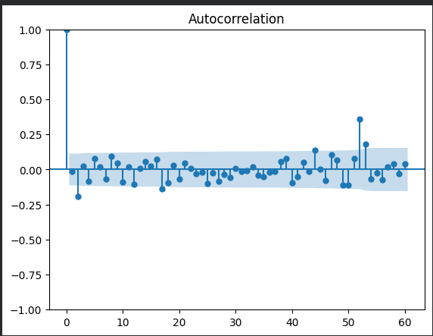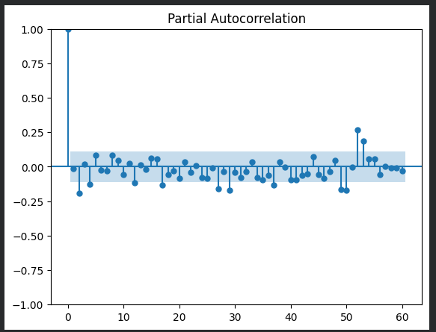
(Figure 6. & 7.Autocorrelation Function (ACF) and Partial Autocorrelation Function (PACF) of Weekly Electricity Demand.)
The null hypothesis of non-stationarity was rejected since the ADF test yielded a p-value below the significance level of 0.05. The null hypothesis of stationarity could not be rejected because the KPSS test yielded a p-value larger than 0.05. The weekly electricity demand series is therefore stagnant, according to both experiments.
Strong temporal relationships and seasonal behavior are present in the dataset, according to the stationarity results as well as the ACF and PACF analysis. Seasonal forecasting models were therefore deemed suitable. SARIMAX expanded on the SARIMA model by incorporating temperature variables as external predictors. The SARIMA model was created utilizing seasonal parameters with an annual seasonal duration of 52 weeks.
5. Forecasting Models
A range of forecasting models, including simple benchmarks and advanced approaches like machine learning, were evaluated for predicting future power consumption using RMSE and MAE criteria. Four benchmark models were developed: Mean Forecast, Naïve Forecast, Seasonal Naïve Forecast, and Drift Forecast. The Naïve Forecast relies on the last observation, which can lead to larger errors, while the Mean Forecast averages data but neglects seasonal variations. The Seasonal Naïve Forecast improves accuracy by using historical seasonal data, though it overlooks changing patterns. The Drift Forecast, which assumes that historical trends will persist unchanged, was the least accurate of the benchmarks..
Table 2. Benchmark Model Performance
 | Model | RMSE | MAE | MASE
0 | Mean | 762.119830 | 646.913283 | 2.591379
1 | Naive | 762.574416 | 652.159760 | 2.612396
2 | Seasonal Naive | 424.459965 | 325.753053 | 1.304889
3 | Drift | 978.935316 | 833.887468 | 3.340353
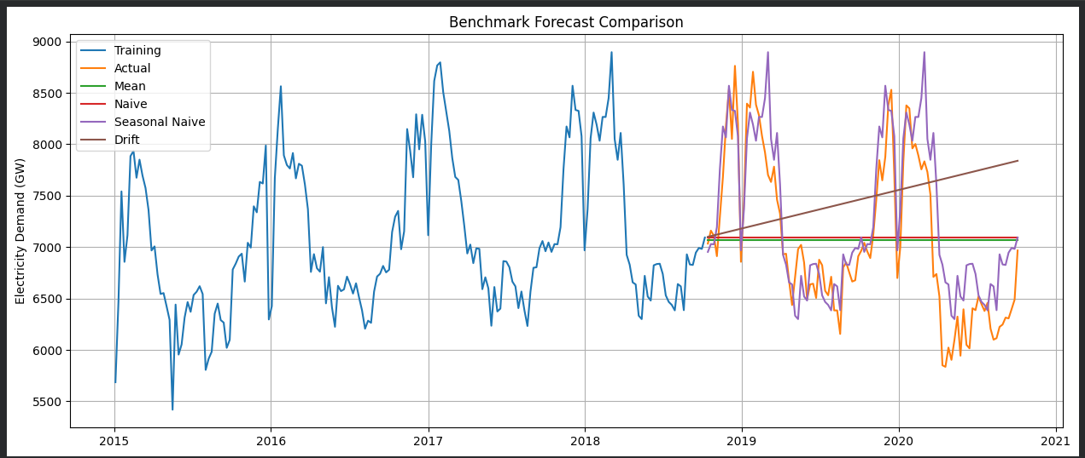
(Figure 8. Benchmark Forecasts Compared with Actual Electricity Demand.)
All things considered, the benchmark findings demonstrate that adding seasonality greatly increases forecasting accuracy. The Seasonal Naïve model outperformed the other straightforward methods by a significant margin, indicating that seasonal behavior is a significant feature of the dataset. To incorporate additional time dependencies and external impacts, however, more sophisticated models are needed.

5.2.SARIMA
To analyze weekly electricity demand, a Seasonal Autoregressive Integrated Moving Average (SARIMA) model was developed, informed by exploratory analysis and stationarity tests, with a seasonal timeframe of 52 weeks chosen due to its annual recurring pattern. The model incorporates autoregressive (AR), differencing (I), moving average (MA), and seasonal elements to capture both short-term dependencies and seasonal behaviors. The best SARIMA parameters were identified through a grid search using the Akaike Information Criterion (AIC) across various non-seasonal parameter combinations (p = 0–6, d = 0–2, q = 0–6) and a fixed seasonal component of (1,1,1,52). The final model, selected for its lowest AIC value, was trained on the dataset to predict electricity consumption for the next two years, with performance evaluated using RMSE and MAE.
Table 3. SARIMA Performance
Model | RMSE | MAE
SARIMA | 522.20 | 430.08

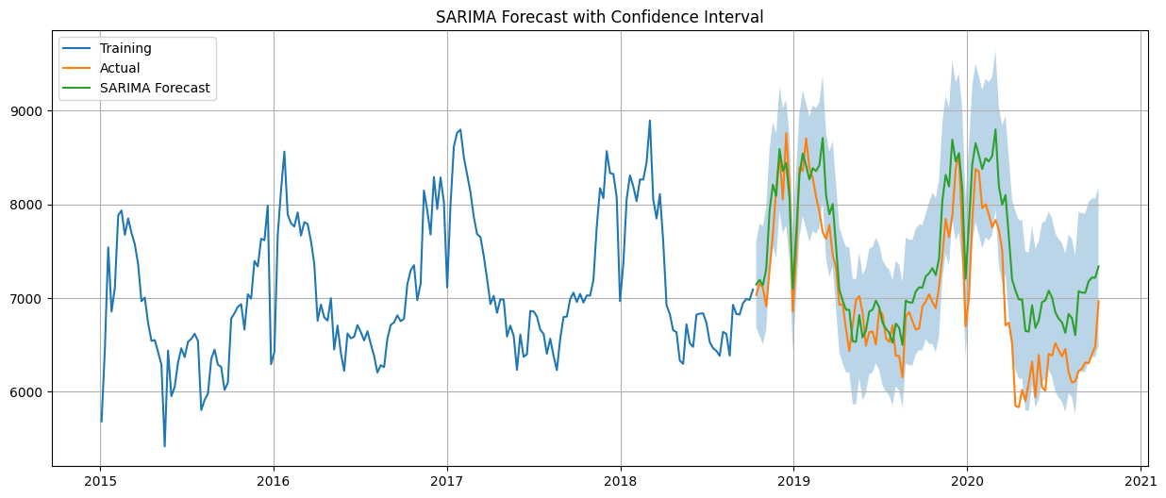
(Figure 9. SARIMA Forecast Compared with Actual Electricity Demand.)
The SARIMA model outperformed basic benchmark models like Mean, Naïve, and Drift forecasts in capturing the overall seasonal pattern of power consumption. But when compared to the actual observations, the projections were more accurate, especially when demand fluctuated quickly. This happens because SARIMA may not adequately capture intricate nonlinear patterns found in data on electricity use because it primarily assumes linear correlations.To determine if the model represented the significant structures in the time series, residual analysis was carried out.
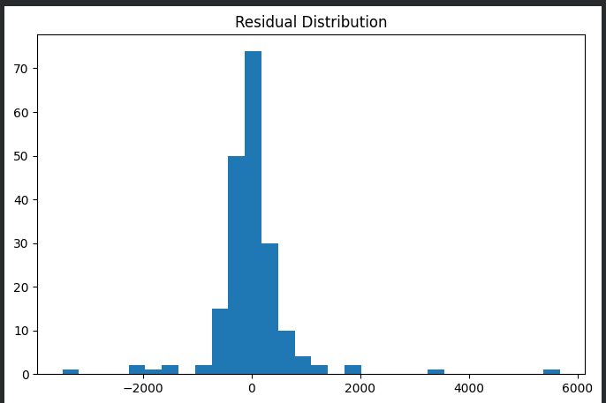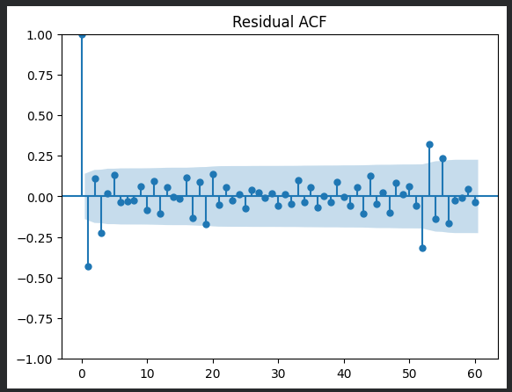
(Figure 10. SARIMA Residual Diagnostics (Residual ACF and Distribution).)
Following modeling, residual plots were examined for autocorrelation, with an emphasis on making sure residuals resembled white noise. The SARIMA model successfully explained the majority of systematic variance, despite some unexplained variation brought on by outside variables like temperature. Forecasts included confidence intervals to account for future demand level uncertainty. The investigation demonstrated that although SARIMA modeling seasonal and autoregressive trends had a solid statistical basis, accuracy might be increased by using nonlinear approaches and external variables.

5.3 SARIMAX Model
The Seasonal Autoregressive Integrated Moving Average with Exogenous Variables (SARIMAX) was used to improve the SARIMA model's forecasting performance. This model takes into account environmental factors that have a big impact on electricity use, like weekly temperature features. Berlin's temperature data, which included heating and cooling degree days as well as metrics like mean, minimum, and maximum temperatures, was used as a stand-in for German weather. Over a period of 52 weeks, the weekly electricity consumption seasonal trend was predicted. The SARIMAX model, which was trained on past power consumption and temperature data, was used to forecast the latest two years of data. Because future temperatures rely on external forecasting systems, it is crucial to remember that temperature data taken during the test period are indicative of future conditions, making the forecast conditional rather than accurately operational.
Table 4. SARIMAX Performance
MODEL | RMSE | MAE
SARIMAX | 478.50 | 364.60

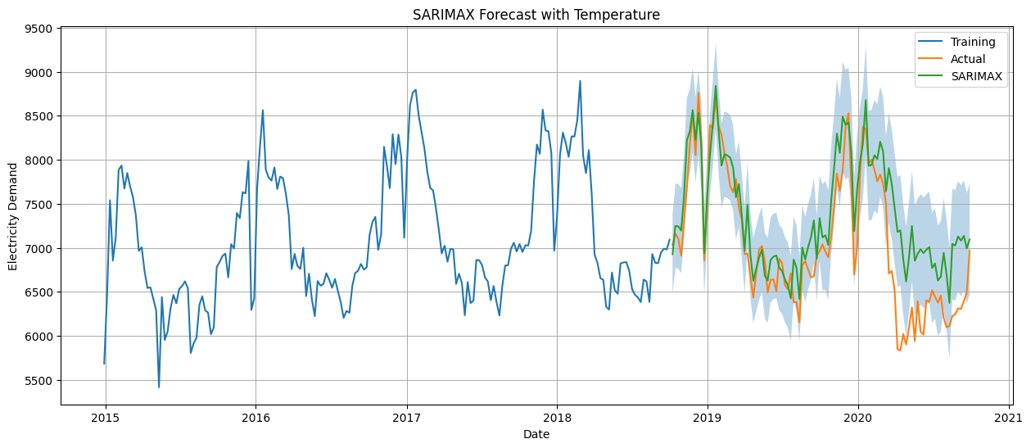
(Figure 11. SARIMAX Forecast Compared with Actual Electricity Demand.)
Incorporating temperature data, the SARIMAX model demonstrated lower RMSE and MAE values compared to SARIMA, indicating superior predictive accuracy. This suggests that external meteorological factors, alongside past electricity usage data, significantly enhance forecasting. Despite limitations due to other variables like holidays and economic activity, SARIMAX effectively captured environmental impacts on electricity demand better than SARIMA. Thus, integrating relevant external variables can improve statistical forecasting models, but practical applications must consider the future availability of these covariates.
5.4 Feature-Based Regression Model (Gradient Boosting Regressor)
A feature-based regression model utilizing Gradient Boosting Regressor was employed to evaluate the enhancement of forecasting capability through machine learning techniques. Unlike SARIMA and SARIMAX, which focus on statistical interactions in time series, machine learning models can capture complex nonlinear relationships. The weekly electricity demand dataset was reformatted into a supervised learning structure by generating lag features from previous demand values and incorporating temperature variables, allowing the model to analyze the influence of historical demand trends and weather conditions on future electricity use.
Table 5. Gradient Boosting Model Performance
MODEL | RMSE | MAE
Gradient Boosting | 274.12 | 206.16

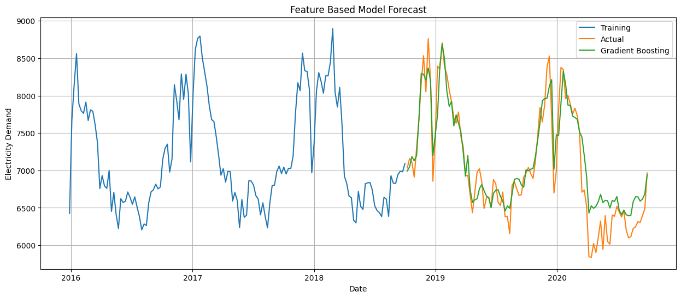
(Figure 12. Gradient Boosting Model Performance)
However, the quality of the chosen features has a significant impact on the model's performance. Although the model outperformed statistical models in terms of accuracy, it is less interpretable and necessitates careful feature engineering. Additional predictors like the impact of holidays, the production of renewable energy, economic indicators, or more specific meteorological data could be included in the future.
All things considered, the Gradient Boosting model shows that feature-based machine learning techniques can significantly outperform conventional statistical forecasting techniques for predicting electricity consumption.
5.5 Long Short-Term Memory (LSTM) Model
The energy demand forecasting performance was improved by using a Long Short-Term Memory (LSTM) neural network. In contrast to conventional statistical models, LSTM does not require assumptions regarding linearity or seasonality in order to learn long-term dependencies from time-series data. Hourly power demand data was standardized and converted into sequential input windows for prediction in this investigation. Early halting was used to avoid overfitting, and a chronological split was used to prevent future data from affecting model training. Over a maximum of 50 epochs, the model was trained with a batch size of 64 while tracking training and validation loss for evaluation.
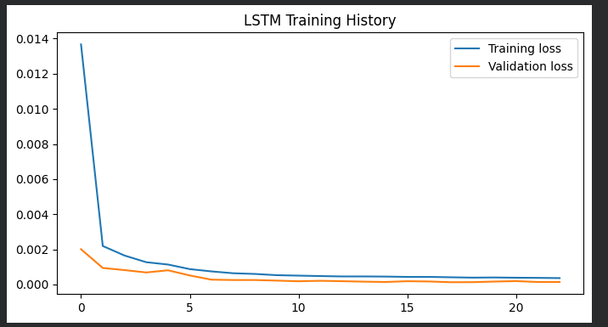
(Figure 13. LSTM Training and Validation Loss.)
Table 6. LSTM Performance
MODEL | RMSE | MAE
LSTM | 122.257 | 94.66
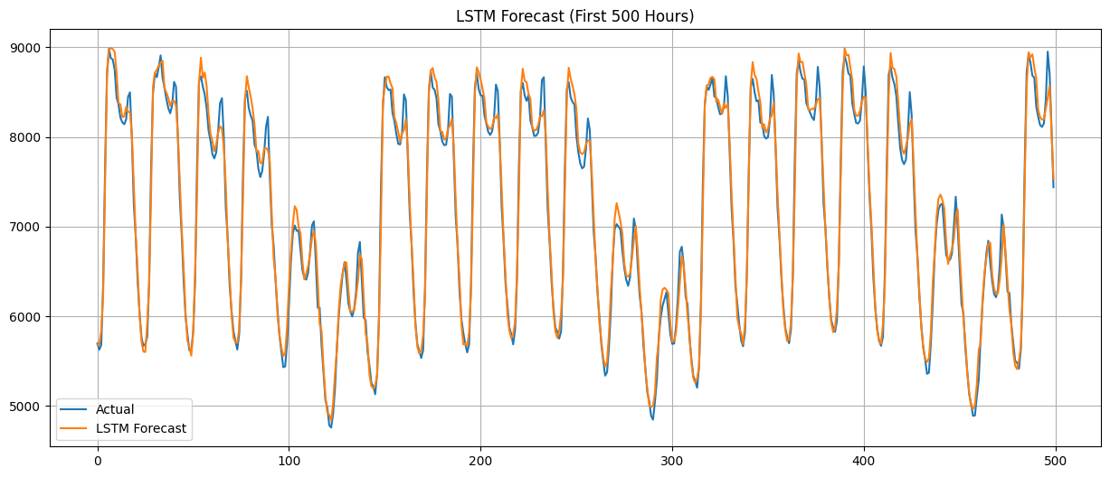
(Figure 14. LSTM Forecast Compared with Actual Electricity Demand.)
With an RMSE of 122.57 and an MAE of 94.66, the LSTM model had the lowest forecasting error of all the models that were put into practice. The forecast closely matches the actual values of power demand, indicating that the model was successful in capturing intricate temporal patterns and data changes.

Because LSTM can learn nonlinear relationships and long-term dependencies from sequential data, it outperformed SARIMA, SARIMAX, and Gradient Boosting in terms of prediction accuracy. But this enhancement is accompanied by more complexity. Compared to statistical forecasting models, LSTM models demand more processing power, longer training times, and careful hyperparameter selection.
Even though LSTM produced the greatest prediction results, interpretability, computational cost, and maintenance needs should all be taken into account when choosing a model for practical use. Therefore, simpler models like SARIMAX may still be helpful when transparency and simplified model administration are crucial, even though LSTM has the maximum accuracy.

6. Comparison and Discussion of Model Performance
RMSE and MAE values were computed for each model in order to compare the performance of all forecasting techniques. Better predicting accuracy is shown by lower values. Simple benchmark methods, statistical models, machine learning models, and deep learning models were all compared.
Model | RMSE | MAE
Mean Forecast | 762.12 | 646.91
Naive Forecast | 762.57 | 652.16
Seasonal Naive | 424.46 | 325.75
Drift | 978.94 | 833.89
SARIMA | 522.20 | 430.08
SARIMAX | 478.50 | 364.60
Gradient Boosting | 274.12 | 206.16
LSTM | 122.57 | 94.66
Table 7.Comparison Table
The Seasonal Naïve model excelled in forecasting electricity demand due to its use of prior seasonal observations, indicating a strong yearly trend, but it cannot adapt to shifts in demand patterns. The SARIMA model improved predictions through autoregressive and seasonal simulations, while SARIMAX slightly surpassed SARIMA by incorporating temperature variables, highlighting the impact of weather on demand. The Gradient Boosting model achieved lower errors by learning nonlinear relationships, but its effectiveness relies on feature quality. The LSTM model recorded the best performance with the lowest RMSE (122.57) and MAE (94.66), effectively capturing complex demand patterns. Used as a benchmark, the Seasonal Naïve model (RMSE = 424.46) showed that while simpler models like SARIMA and SARIMAX are easier to understand, they perform less well in nonlinear contexts compared to LSTM and Gradient Boosting. SARIMAX remains a viable option for operational forecasting, balancing interpretability and efficiency.
7. Conclusion
In order to forecast German electricity demand, this research looked into various time-series forecasting techniques.
Stationarity tests (ADF and KPSS) and exploratory data analysis demonstrate that electricity consumption follows clear seasonal trends. These seasonal and autoregressive characteristics are well modeled by SARIMA and SARIMAX models, which outperform more straightforward techniques like Mean and Naïve, with the Seasonal Naïve model demonstrating remarkable effectiveness. Forecasting accuracy is improved by deep learning techniques, particularly LSTM and Gradient Boosting. By capturing intricate temporal patterns, LSTM achieves the lowest RMSE (122.57) and MAE (94.66). Although LSTM is more accurate, it requires more resources and is harder to understand than SARIMAX, which is better for maintainability. Future enhancements might include modifying the model and adding external variables, demonstrating the potential of integrating machine learning and time-series analysis for improved predicting outcomes.
References
- Box, G. E. P., Jenkins, G. M., Reinsel, G. C., & Ljung, G. M. Time Series Analysis: Forecasting and Control. 5th Edition, Wiley, 2015.
- Hyndman, R. J., & Athanasopoulos, G. Forecasting: Principles and Practice. 3rd Edition, OTexts, 2021.
- Hochreiter, S., & Schmidhuber, J. (1997). "Long Short-Term Memory." Neural Computation, 9(8), 1735–1780.
- Friedman, J. H. (2001). "Greedy Function Approximation: A Gradient Boosting Machine." The Annals of Statistics, 29(5), 1189–1232.

